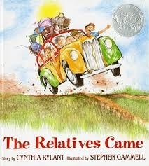
The Relatives Came
BY CYNTHIA RYLANT
It was in the summer of the year when the relatives came. They came up from Virginia. They left when their grapes were nearly purple enough to pick, but not quite. They had an old station wagon that smelled like a real car, and in it they put an ice chest full of soda pop and some boxes of crackers and some bologna sandwiches, and they came from Virginia.
They left at four in the morning when it was still dark, before even the birds were awake. They drove all day long and into the night, and while they traveled along they looked at strange houses and different mountains and they thought about their almost purple grapes back home. They thought about Virginia—but they thought about us, too. Waiting for them. So they drank up all their pop and ate up all their crackers and traveled up all those miles until finally they pulled into our yard.
Then it was hugging time. Talk about hugging! Those relatives just passed us all around their car, pulling us against their wrinkled Virginia clothes, crying sometimes. They hugged us for hours. Then it was into the house and so much laughing and shining faces and hugging in the doorways. You'd have to go through at least four different hugs to get from the kitchen to the front room. Those relatives! And finally after a big supper two or three times around until we all got a turn at the table, there was quiet talk and we were in twos and threes through the house.
The relatives weren't particular about beds, which was good since there weren't any extras, so a few squeezed in with us and the rest slept on the floor, some with their arms thrown over the closest person, or some with an arm across one person and a leg across another. It was different, going to sleep with all that new breathing in the house.
The relatives stayed for weeks and weeks. They helped us tend the garden and they fixed any broken things they could find. They ate up all our strawberries and melons, then promised we could eat up all their grapes and peaches when we came to Virginia. But none of us thought about Virginia much. We were so busy hugging and eating and breathing together.
Finally, after a long time, the relatives loaded up their ice chest and headed back to Virginia at four in the morning. We stood there in our pajamas and waved them off in the dark. We watched the relatives disappear down the road, then we crawled back into our beds that felt too big and too quiet. We fell asleep.
And the relatives drove on, all day long and into the night, and while they traveled along they looked at the strange houses and different mountains and they thought about their dark purple grapes waiting at home in Virginia. But they thought about us, too. Missing them. And they missed us. And when they were finally home in Virginia, they crawled into their silent, soft beds and dreamed about next summer. •

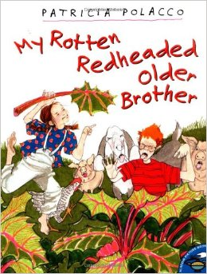
My Rotten Redheaded Older Brother
by Patricia Polacco
My brother and our mother and I all lived with my grandparents on their farm in Union City, Michigan.
Now my babushka, my grandmother, knew lots of things. She knew just how to tell a good story. She knew how to make ordinary things magical. And she knew how to make the best chocolate cake in Michigan.
After she told my brother and me a grand tale from her homeland, we'd always ask, "Bubbie, is that true?"
She'd answer, "Of course is true, but it may not have happened!" Then she'd laugh.
Now, I knew that she loved me all right, but I couldn't quite understand how she could even like my brother, Richard. He had orange hair that was like wire; he was covered in freckles and looked like a weasel with glasses.
The one thing that my bubbie didn't seem to know was how perfectly awful my brother really was! Mind you, he was always nice whenever she was around us; but as soon as she'd leave, he would do something terrible to me and laugh.
There were so many things that I couldn't stand about him. The worst was that he was always telling me he could do just about everything better than I.
"Bet I can pick more blackberries than you can, "he jeered at me one day.
"No you can't."
"Can so."
"Cannot!"
"Can," he whispered.
"Not," I said louder.
"Can!" he whispered so low that I could hardly hear him.
"Not!"I screamed back.
We both picked berries for most of the afternoon. Well, he upped and did it! He not only picked more berries than I, he set a record that wasn't even challenged for the next ten years.
"You make me sick, Richard Barber!" I yelled at him.
Then he smiled that smile that only a rotten redheaded older brother could smile.
I guess I would have to face it. He could run the fastest, climb the highest, throw the farthest, sit the longest, get the dirtiest, burp the loudest, and spit the farthest. He had no equal, certainly not me!
"And I'm four years older than you... Always have been and always will be," he sneered.
There had to be something SOMETHING I could do that he couldn't!
Then an inspired thought comforted me like a fresh breeze on a hot summer day.
"Oh, Richie," I cooed as I stood next to the rhubarb bushes. "Do you like rhubarb?"
"No!" he said. "It's the sourest stuff on this planet!"
Now I knew, at long last, that I had him.
"Bet I can eat more of this raw rhubarb that you can without getting the puckers!"I challenged.
"I don't think so!"
"I do!"
"I don't!" he said, narrowing his eyes.
"I do!"I insisted.
"Don't," he hissed, looking smug.
‘"Do," I said furiously as I grabbed the first stalk and started chewing it almost down to the leaf.
When I couldn't get one more sour bite into my mouth, he was still eating with relish."I thought you said you don't like rhubarb," I said through pursed lips.
"I don't like it...I LOVE it!" he announced as he popped the last stalk into his mouth.
I was so mad, I couldn't even feel how my belly was starting to ache. "I can't stand you, Richard Barber... I double dog can't stand it!" I screamed as I went into the house to be consoled by my grandmother.
"Yeah, and I'm four years older than you, too, you little twerp... Always have been and always will be!" he called after me. Then he laughed that rotten redheaded older brother laugh.
That night at dinner I could hardly eat.
"Have you been eating angry apples again, child?" Bubbie asked as she sliced me a huge wedge of rhubarb pie."I baked your favorite!"
Richard gave me one of his extra-rotten, weasel-eyed, greeny-toothed grins.
At bedtime my bubbie came and sat on the edge of my bed like she did every night."Look, a falling star," she said.
We watched it streak across the sky. Then she spit twice between her fingers and gave her chest a loud slap.
"Why did you do that, Bubbie?"I asked.
"I was making a wish...Didn't you know that wishes on falling stars come true?"
At last I knew how I was going to get back at my brother.
For the longest time I watched the dark sky until I saw a star across the night. Then I spit between my two fingers and slapped my chest.
It was done.
My wish was to do something - anything - better than my brother. I'd show him!
The next morning all I could think about was my wish. I was thinking about it so hard I almost didn't notice the wagons and trucks pulling into the field down the road near Four Corners.
"A traveling carnival," my brother shouted as he ran toward me."They're setting up right here in our field! I bet I can eat more hot dogs than you can," he teased.
He was already starting it, but this time I was going to do something so incredible that even he would have to sit up and take notice. I had a star wish... I'd show my rotten redheaded brother all right!
That night I ran straight for the merry-go-round.
We must have taken fifty turns on that carousel. But then my brother got off!
I stayed on. I went around and around and around.
"I knew I could do this longer than you," I shouted to my brother, feeling proud but just a bit dizzy.
"Treesha," I heard my bubbie call out."Get off from that thing... It's time to go home!"
The last thing I remembered was stepping off from the platform. Next thing I knew I woke up with Bubbie sitting on the edge of my bed. Mom and Grandpa were there, too.

"You gave us all fright!"Momma said. "How do you feel?"
"What happened?"I asked.
"You fell!" my rotten redheaded older brother announced with the biggest grin on his face.
"I don't know what we would have done," my Bubbie said softly."Your brother carried you all the way home, and then he had to run to get Dr. Lee."
"You had to have stitches...I watched it all!" he said excitedly.
"You fell off the merry-go-round right into some pop bottles," my gramps added.
"You even passed out!" my brother chirped. "Looks like you finally did something special!"
It was from that exact moment that our relationship changed somehow.
"Thanks, Richie," I said to him.
"What's a big brother for, anyway," he said blushing.
That night we were all out in the yard. On hot Michigan nights it was my family's custom to sleep outside, where it was cool.
"Look at those stars," Bubbie said quietly.
"Wishes are funny, aren't they," I said."Sometimes they come true differently than you think they will."
"That's why you have to be very careful what you wish for...it just may come true!" Bubbie said. Then she squeezed both of our hands."Hang onto the grass," she whispered.
"Why, Bub?" my brother asked.
"Because if we don't we might float up to the stars." Then she leaned over and kissed us both three times.
"I kiss your eyes, and I hold both of your hearts in my good keeping... And this night I thank God that I walk this earth with both of you... Ah-men!"
Then we all just lay on our blankets in the gentle summer night.
"I'll always be four years older than you, though," my brother whispered softly. Then he smiled.
All of us held one another hands, and then we all drifted off to sleep.

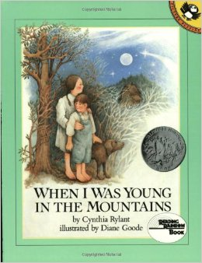
When I Was Young in the Mountains
By: Cynthia Rylant

When I was young in the mountains, Grandfather came home in the evening covered with the black dust of a coal mine. Only his lips were clean, and he used them to kiss the top of my head.

When I was young in the mountains, Grandmother spread the table with hot corn bread, pinto beans and fried okra.

Later, in the middle of the night, she walked through the grass with me to the Johnny-house and held my hand in the dark. I promised never to eat more than one serving of okra again.

When I was young in the mountains, we walked across the cow pasture and through the woods, carrying our towels. The swimming hole was dark and muddy, and we sometimes saw snakes, but we jumped in anyway.

On our way home, we stopped at Mr. Crawford’s for a mound of white butter. Mr. Crawford and Mrs. Crawford looked alike and always smelled of sweet milk.

When I was young in the mountains, we pumped pails of water from the well at the bottom of the hill, and heated the water to fill round tin tubs for our baths.

Afterward we stood in front of the old black stove, shivering and giggling, while Grandmother heated cocoa on top.

When I was young in the mountains, we went to church in the schoolhouse on Sundays, and sometimes walked with the congregation through the cow pasture to the dark swimming hole, for baptisms.

My cousin Peter was laid back into the water, and his white shirt stuck to him, and my grandmother cried.

When I was young in the mountains, we listened to frogs sing at dusk and awoke to cowbells outside our windows. Sometimes a black snake came in the yard, and my Grandmother would threaten it with a hoe.

If it did not leave, she used to hoe to kill it. Four of us once draped a very long snake, dead of course, across our necks for a photograph.

When I was young in the mountains, we sat on the porch swing in the evenings and grandfather sharpened my pencils with his pocketknife. Grandmother sometimes shelled beans and sometimes braided my hair. The dogs lay around us, and the stars sparkled in the sky. A bobwhite whistled in the forest. Bob-bob-bobwhite!

When I was young in the mountains, I never wanted to go to the ocean, and I never wanted to go to the desert. I never wanted to go anywhere else in the world, for I was in the mountains. And that was always enough.

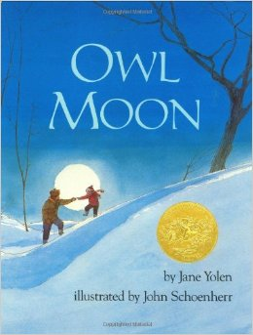
Owl Moon
By Jane Yolen

It was late one winter night, long past my bedtime, when Pa and I went owling. There was no wind. The trees stood still as giant statues. And the moon was so bright the sky seemed to shine. Somewhere behind us a train whistle blew, long and low, like a sad, sad song.
I could hear it through the woolen cap Pa had pulled down over my ears. A farm dog answered the train, and then a second dog joined in. They sang out, trains and dogs, for a real long time. And when their voices faded away it was as quiet as a dream. We walked on towards the woods, Pa and I.

Our feet crunched over the crisp snow and little gray footprints followed us. Pa made a long shadow, but mine was short and round. I had to run after him every now and then to keep up, and my short, round shadow bumped after me. But I never called out. If you go owling you have to be quiet, that’s what Pa always says. I had been waiting to go owling with Pa for a long, long time.

We reached the line of pine trees, black and pointy against the sky, and Pa held up his hand. I stopped right where I was and waited. He looked up, as if searching the stars, as if reading a map up there. The moon made his face into a silver mask.

Then he called: “Whoo-whoo-who-who-who-whooooooo,” the sound of a Great Horned Owl.

“Whoo-whoo-who-who-who-whooooooo.”

Again he called out. And then again. After each all he was silent and for a moment we both listened. But there was no answer. Pa shrugged and I shrugged. I was not disappointed. My brothers all said sometimes there’s an owl and sometimes there isn’t.
We walked on. I could feel the cold, as if someone’s icy hand was palm-down on my back. And my nose and the tops of my cheeks felt cold and hot at the same time. But I never said a word. If you go owling you have to be quiet and make your own heat.

We went into the woods. The shadows were the blackest things I had ever seen. They stained the white snow. My mouth felt furry, for the scarf over it was wet and warm. I didn’t ask what kinds of things hide behind black trees in the middle of the night. When you go owling you have to be brave.

Then we came to a clearing in the dark woods. The moon was high above us. It seemed to fit exactly over the center of the clearing and the snow below it was whiter than the milk in a cereal bowl.

I sighed and Pa held up his hand at the sound. I put my mittens over the scarf over my mouth and listened hard.

And then Pa called: “Whoo-whoo-who-who-who-whooooooo. Whoo-whoo-who-who-who-whooooooo.”

I listened and looked so hard my ears hurt and my eyes got cloudy with the cold. Pa raised his face to call out again, but before he could open his mouth an echo came threading its way through the trees.
“Whoo-whoo-who-who-who-whooooooo.”
Pa almost smiled. Then he called back: “Whoo-whoo-who-who-who-whooooooo,” just as if he and the owl were talking about supper or about the woods or the moon or the cold. I took my mitten off the scarf off my mouth, and I almost smiled, too.

The owl’s call came closer, from high up in the trees on the edge of the meadow. Nothing in the meadow moved. All of a sudden an owl shadow, part of a big tree shadow, lifted off and flew right over us. We watched silently with heat in our mouths, the head of all those words we had not spoken. The shadow hooted again.

Pa turned on his big flashlight and caught the owl just as it was landing on a branch.

For one minute, three minutes, maybe even a hundred minutes, we stared at one another.

Then the owl pumped its great wings and lifted off the branch like a shadow without sound. It flew back into the forest.

“Time to go home,” Pa said to me.

I knew then I could talk, I could even laugh out loud. But I was a shadow as we walked home.

When you go owling you don’t need words or warm or anything but hope. That’s what Pa says. The kind of hope that flies on silent wings under a shining Owl Moon.

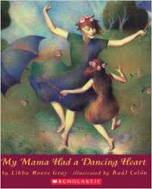
My Mama Had a Dancing Heart
BY LIBBA MOORE GREY

My Mama had a dancing heart and she shared that heart with me.

With a grin and a giggle, a hug and a whistle, we'd slap our knees and Mama would say: "Bless the world it feels like a tip-tapping song-singing finger-snapping kind of day. Let's celebrate!" And so we did.

When a warm spring rain would come pinging on the windowpane, we'd kick off our shoes and out into the rain we'd go.

We'd dance a frog-hopping leaf-growing flower-opening hello spring ballet.

High-stepping and splashing, the rain running down our faces, I'd slip-swish behind Mama through the newly green grass.

And afterward we'd read rain poems and drink sassafras tea with lemon curls floating.

And in the summer when the waves would come splash-splashing on the shore, out we'd go into the red-orange morning with kites and balloons tied to our wrists.

We'd do a seabird-flapping dolphin-arching hello summer ballet, with me following Mama, the sand stuck between the toes of our up-and-down squish-squashing feet.

And afterward we'd seashell-pile the windowsill and drink lemonade cold.

And when the cool autumn winds would come puff-puffing through the clouds, and the hold-on-tight leaves would finally let go and float-flutter to the ground, out we'd go into the eye-blinking blue air, with Mama leading in a leaf-kicking leg-lifting hand-clapping hello autumn ballet.
And afterward we'd wax paper-press leaves red and gold and drink hot tea spiced.

And when the winter snows came softly down shawling the earth, out we'd go and do a body-flat arms-moving-up-and-down snow-angel hello winter ballet.

And then we'd stand up, Mama first, and dance in slow motion, like hand-mittened galoshes-galumphing funny old snowmen.

And afterward we'd cut snowflakes paper-white delicate and sip cocoa with marshmallows floating.

And now after satin-ribboning my feet and listening to the violins sing-swelling around me, onto the stage I go air-daring leap-flying wing-soaring letting the spring rain summer waves autumn leaves winter snow carry me along until the music slows and I feather-float down... down to the ground.

And afterward I imagine that I hear my mama saying: "Bless the world it feels like a tip-tapping song-singing finger-snapping kind of day. Let's celebrate!"
My Mama had a dancing heart and she shared that heart with me. •

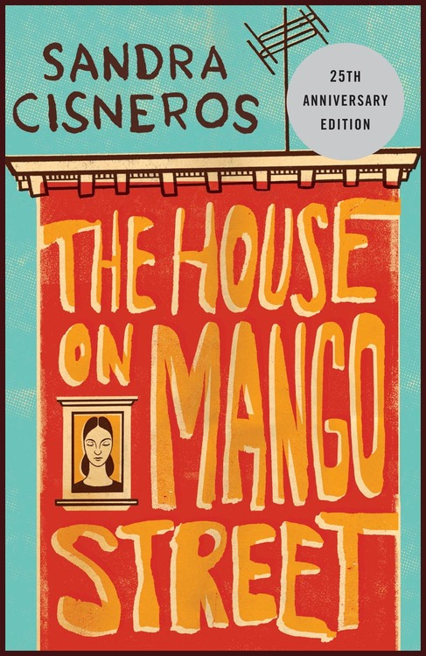
Papa Who Wakes Up Tired in the Dark

Your abuelito is dead, Papa says early one morning in my room. Esta’ muerto, and then as if he just heard the news himself, crumples like a coat and cries, my brave Papa cries. I never seen my Papa cry and don’t know what to do.
I know he will have to go away, that he will take a plane to Mexico, all the uncles and aunts will be there, and they will have a black-and-white photo taken in front of the tomb with flowers shaped like spears in a white vase because this is how they send the dead away in that country.
Because I am the oldest, my father has told me first, and now it is my turn to tell the others. I will have to explain why we can’t play. I will have to tell them to be quiet today.
My Papa, his thick hands and thick shoes, who wakes up tired in the dark, who combs his hair with water, drinks his coffee, and is gone before we wake, today is sitting on my bed.
And I think if my own Papa died what would I do. I hold my Papa in my arms. I hold and hold and hold him.

From The House on Mango Street by Sandra Cisneros

“Eleven”
by Sandra Cisneros

What they don't understand about birthdays and what they never tell you is that when you're eleven, you're also ten, and nine, and eight, and seven, and six, and five, and four, and three, and two, and one. And when you wake up on your eleventh birthday you expect to feel eleven, but you don't. You open your eyes and everything's just like yesterday, only it's today. And you don't feel eleven at all. You feel like you're still ten. And you are—underneath the year that makes you eleven.

Like some days you might say something stupid, and that's the part of you that's still ten. Or maybe some days you might need to sit on your mama's lap because you're scared, and that's the part of you that's five. And maybe one day when you're all grown up maybe you will need to cry like if you're three, and that's okay. That's what I tell Mama when she's sad and needs to cry. Maybe she's feeling three.

Because the way you grow old is kind of like an onion or like the rings inside a tree trunk or like my little wooden dolls that fit one inside the other, each year inside the next one. That's how being eleven years old is.

You don't feel eleven. Not right away. It takes a few days, weeks even, sometimes even months before you say Eleven when they ask you. And you don't feel smart eleven, not until you're almost twelve. That's the way it is.

Only today I wish I didn't have only eleven years rattling inside me like pennies in a tin Band-Aid box. Today I wish I was one hundred and two instead of eleven because if I was one hundred and two I'd have known what to say when Mrs. Price put the red sweater on my desk. I would've known how to tell her it wasn't mine instead of just sitting there with that look on my face and nothing coming out of my mouth.

"Whose is this?" Mrs. Price says, and she holds the red sweater up in the air for all the class to see. "Whose? It's been sitting in the coatroom for a month."

"Not mine," says everybody, "Not me."

"It has to belong to somebody," Mrs. Price keeps saying, but nobody can remember. It's an ugly sweater with red plastic buttons and a collar and sleeves all stretched out like you could use it for a jump rope. It's maybe a thousand years old and even if it belonged to me I wouldn't say so.

Maybe because I'm skinny, maybe because she doesn't like me, that stupid Sylvia Saldivar says, "I think it belongs to Rachel." An ugly sweater like that all raggedy and old, but Mrs. Price believes her. Mrs Price takes the sweater and puts it right on my desk, but when I open my mouth nothing comes out.

"That's not, I don't, you're not . . . Not mine." I finally say in a little voice that was maybe
me when I was four.

"Of course it's yours," Mrs. Price says. "I remember you wearing it once." Because she's older and the teacher, she's right and I'm not.

Not mine, not mine, not mine, but Mrs. Price is already turning to page thirty-two, and math problem number four. I don't know why but all of a sudden I'm feeling sick inside, like the part of me that's three wants to come out of my eyes, only I squeeze them shut tight and bite down on my teeth real hard and try to remember today I am eleven, eleven. Mama is making a cake for me for tonight, and when Papa comes home everybody will sing Happy birthday, happy birthday to you.

But when the sick feeling goes away and I open my eyes, the red sweater's still sitting there like a big red mountain. I move the red sweater to the corner of my desk with my ruler. I move my pencil and books and eraser as far from it as possible. I even move my chair a little to the right. Not mine, not mine, not mine.

In my head I'm thinking how long till lunchtime, how long till I can take the red sweater and throw it over the schoolyard fence, or leave it hanging on a parking meter, or bunch it up into a little ball and toss it in the alley. Except when math period ends Mrs. Price says loud and in front of everybody, "Now, Rachel, that's enough," because she sees I've shoved the red sweater to the tippy-tip corner of my desk and it's hanging all over the edge like a waterfall, but I don't care.

"Rachel," Mrs. Price says. She says it like she's getting mad. "You put that sweater on right now and no more nonsense."

"But it's not—"
"Now!" Mrs. Price says.

This is when I wish I wasn't eleven because all the years inside of me—ten, nine, eight, seven, six, five, four, three, two, and one—are pushing at the back of my eyes when I put one arm through one sleeve of the sweater that smells like cottage cheese, and then the other arm through the other and stand there with my arms apart like if the sweater hurts me and it does, all itchy and full of germs that aren't even mine.

That's when everything I've been holding in since this morning, since when Mrs. Price put the sweater on my desk, finally lets go, and all of a sudden I'm crying in front of everybody. I wish I was invisible but I'm not. I'm eleven and it's my birthday today and I'm crying like I'm three in front of everybody. I put my head down on the desk and bury my face in my stupid clown-sweater arms. My face all hot and spit coming out of my mouth because I can't stop the little animal noises from coming out of me until there aren't any more tears left in my eyes, and it's just my body shaking like when you have the hiccups, and my whole head hurts like when you drink milk too fast.

But the worst part is right before the bell rings for lunch. That stupid Phyllis Lopez, who is even dumber than Sylvia Saldivar, says she remembers the red sweater is hers! I take it off right away and give it to her, only Mrs. Price pretends like everything's okay.

Today I'm eleven. There's a cake Mama's making for tonight and when Papa comes home from work we'll eat it. There'll be candles and presents and everybody will sing Happy birthday, happy birthday to you, Rachel, only it's too late.

I'm eleven today. I'm eleven, ten, nine, eight, seven, six, five, four, three, two, and one, but I wish I was one hundred and two. I wish I was anything but eleven, because I want today to be far away already, far away like a runaway balloon, like a tiny “o” in the sky, so tiny tiny you have to close your eyes to see it.

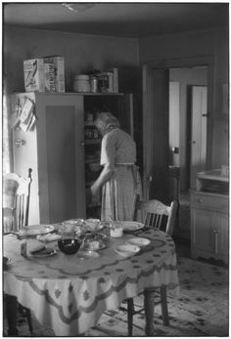
Grandmama’s Kitchen Table
BY CYNTHIA RYLANT

Since I was four years old I have been talking about my life to the people who sit at my grandmama's kitchen table in Cool Ridge, West Virginia.
The kitchen is small and skinny. There is a little window next to Grandmama's table, and this is where she sits when she is alone in the house. Outside she can see the birds at the apple tree, eating the seed she left them, and she can see who's driving up the hollow, or whose child is walking out the dirt road to the school bus. There are woods all around, and her eyes will follow them down past the creek, down past Bill Mills' house, and on.
When I am visiting, I make sure I never sit in Grand mama’s chair. I want her to have her little window.
Relatives will come by-Uncle Dean and Aunt Linda, Sue and the girls, Bev and the baby -and all sit on a bench in the doorway or on an extra chair that will block anybody who's trying to get through the room. But no one wants to go into the living room, where there are plenty of seats for us all. We want to be in Grandmama's kitchen, near this heavy old table, and we want to drink coffee and tea and Coke and eat angel food cake or leftover biscuits and talk and talk and talk and talk until we are all talked out, and there is nothing left to do but go on home and rest up and come back tomorrow to talk some more.

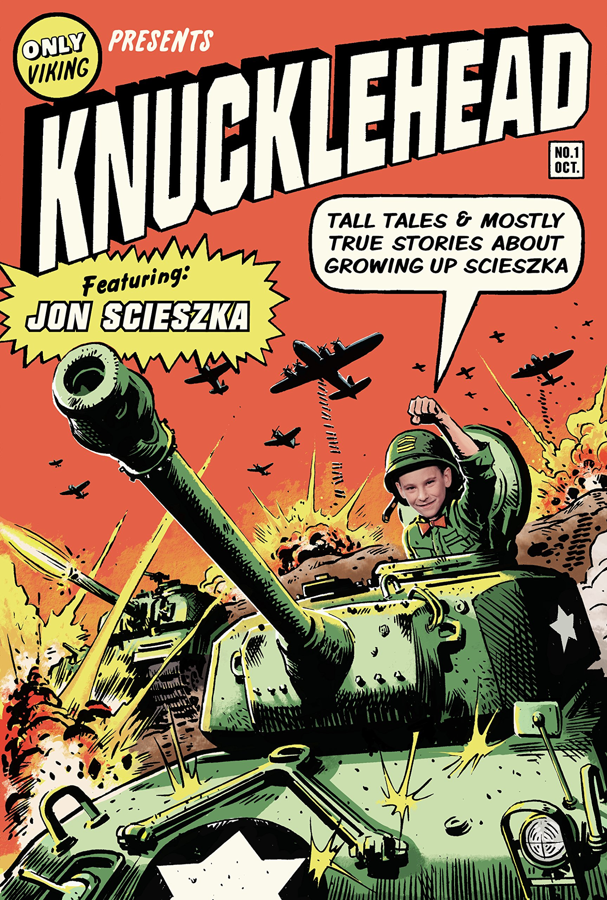
JON SCIESZKA
Roommates (excerpt from Knucklehead)
Since there were six boys, it worked out just right that everyone had a roommate: Jim and Jon, Tom and Gregg, Brian and Jeff.
It worked out pretty well for me because Jim was neat and not too much of a pain in the neck like the little brothers. But man, could Jim talk.
I think Jim knew from the time he was four that he was going to be a lawyer. He was always trying to win an argument or make a case why you should agree with him. Jim would talk and talk, and then talk some more.
His best pitch ever was the time he tied to sell me my own shirt.
I was looking for a clean shirt to wear. Most of the clothes were in a pile on the floor of my closet. I was digging through the pile, sniffing for one that was not too smelly.
Jim pulled a clean, folded, short-sleeved shirt out of his dresser drawer.
“I really should save this shirt, Jon. But because you need it, I’m going to give you a deal,” said Jim.
I found a shirt with only a couple of grass stains on the elbows.
“What’s that?” I said.
“This is an excellent shirt, a clean shirt, a lightweight shirt, a short-sleeved shirt,” said Jim. “But because you need it, I’m going to give it to you for a bargain price.”
I held up a pretty good-looking dark blue shirt. It smelled like the two-week-old socks still hanging on it.
“Look at this shirt. It’s a great shirt. Probably the best shirt,” said Jim. “And I am going to let you have it, while I wear my same old shirt, for only fifty cents.”
I looked at the shirt. It was a great shirt.
“It’s perfectly clean,” said Jim.
He was right. It was perfectly clean.
I checked the pockets.
“I’ve only got twenty-five cents,” I said.
Jim put the shirt back in his drawer.
“I’m afraid I can’t go any lower than forty cents. It’s my only clean shirt. I’m going to need it soon. I was going to do you a favor, but I can see it’s not going to work out.”
I tried on a brown shirt. It smelled even worse than the green shirt.
“Maybe I can get twenty-five cents off Tom,” I said. “Let me see the shirt.”
Jim handed it over. I tried it on. It fit perfectly. It was clean. It was so…familiar.
“Hey,” I said. “This is my shirt.”
“It was in my drawer,” said Jim. “You owe me fifty cents.”
“I do not.”
“You do too.”
“Do not.”
“Take it off.”
“Make me.”
Our legal debate quickly turned into a wrestling match. Jim jumped on me. I got him in a headlock. We rolled around on our bedroom floor. And I think I made Jim a better, stronger lawyer.

Scieszka, Jon. "Roommates (Excerpt from Knucklehead)." Jon Scieszka Presents Guys Write for Guys Read. New York: Penguin Group, 2005. 10-11.

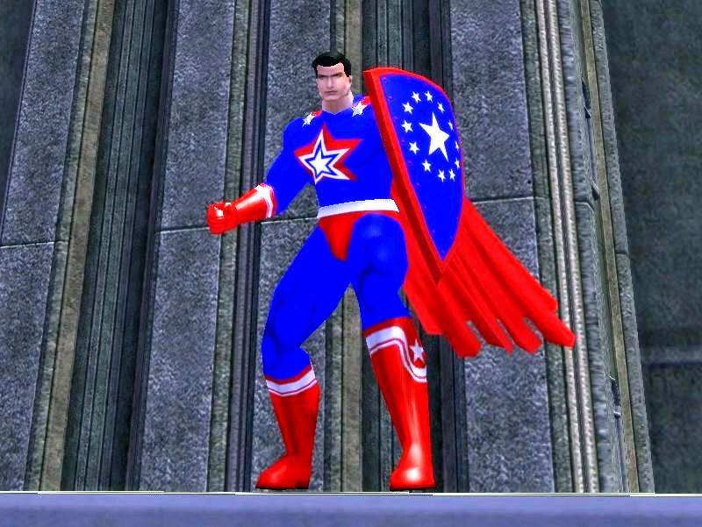
AVI
Superpatriot

Superman. Batman. Robin. Wonder Woman. The Flash. Hawkman. Plastic Man. The Green Lantern. Captain America. Captain Marvel Junior. Mary Marvel. Uncle Marvel. Best of all, Captain Marvel. To name only the important ones.
They may have been comic book characters to some people, but they were my role models. Hardly a coincidence that all these superheroes went through life pretending (like me) to be normal. With a quick change of costume (better than underwear) or, in the case of Billy Barson, at the utterance of a magic word- Shazam!- they turned into superheroes. They didn’t just right the wrongs in the world; they always thought of other people. Not one selfish or self-serving bone in their muscular bodies. No wonder that, having worked hard to defeat our enemies during World War II, they were great patriots.
I never could read enough about them. But then I was aiming to be a superhero. After all, I had mastered half the role- being, like Clark Kent, mild mannered.
Then I learned the truth about myself.
It happened in 1946. Right after the war. I was nine years old. Hospitals were full of wounded military personnel. Somehow I learned that they, too, liked comic books. As they convalesced, they would enjoy some.
I decided to hold a comic book drive at my school, Public School Eight. During the war, there were many such patriotic collection efforts. Newspapers. Scrap metal. Even string. So when I asked my teacher if I could organize a comic book collection drive for “our boys” in hospitals, I received an enthusiastic “OK.”
To announce this drive, I went from class to class and spoke about how our boys had sacrificed a lot for us. How unselfish they were. That by giving them our beloved comics, we, too, could be unselfish patriots. I spoke at the weekly assembly, making a rousing patriotic speech. I was praised. My parents were praised. And the comic books came pouring in.
Hundreds of them. Sure, there were some Little Lulus, and Archies- girl comic books- but so what? I read each and every one of them. I read them in the morning before school. After school. At night. I read them under the covers. In the bathtub. At the dinner table. On the toilet.
“Don’t you think you should send them off to the hospital?” my mother prodded. She had found a place to send them- along with an address and a willingness to pay the postage.
“I haven’t finished reading them all,” I said.
“Who are they for?” she asked.
I was too busy reading to answer.
A month later, I came home from school and discovered she had scooped them up, packaged them, and sent them off.
I was mad. “They were mine!” I protested.
“Oh?” she replied, with a lift of one eyebrow.
A few weeks later I received a letter from the hospital. They thanked me lavishly. Told me how much the boys enjoyed the gift. The last line read, “America is great because of unselfish patriots like you.”
Soon as I read that line, I knew- as sure as I knew anything- that my motives had not been pure. I wanted to read those comic books myself. I had been selfish. I was not going to be a superhero.
Oh, I kept on reading about superheroes. But I was reading about them, not me. It was clear even to me that I was doomed to remain just…mild mannered.

Avi. "Superpatriot." Jon Scieszka Presents Guys Write for Guys Read. New York: Penguin Group, 2005. 25-27.

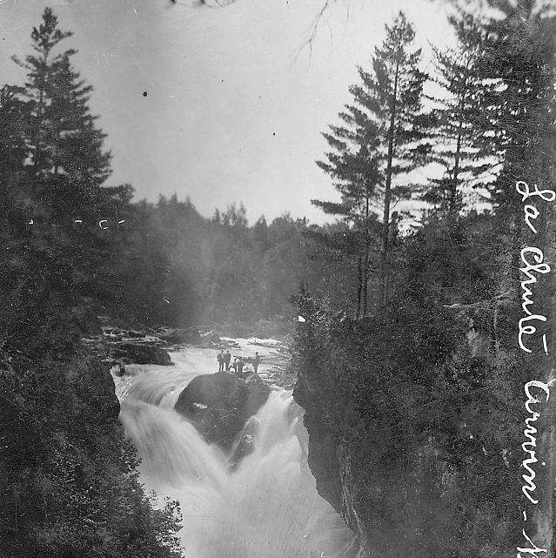
T.A. BARRON
The Crossing
There it was the deepest gorge I’d ever seen.
Like a bottomless gash in the mountainside, this gorge opened under the waterfall that had poured here relentlessly, season after season, century after century. Water slammed down into it, smashing the granite cliff walls, thundering like a thousand storms. Mist exploded upward, rising and billowing into the sky.
I stood there, watching, leaning against a mossy boulder. “The crossing.” That was what the ancient Anasazi name for this gorge meant. Was there something special about those cliff walls on the other side? And if not, why would the Anasazi have ever tried to cross over that churning, crashing death trap?
I bit through the straw I was chewing. One way to find out, right?
Carefully, I stepped over the slippery, spray-soaked rocks to the edge of the chasm. Pulling off my backpack, I hooked my foot through one of the straps so that the pack’s weight would hold me back. Carefully, very carefully, I leaned over into the gorge.
A blast of water slapped my face, cold as the icy glaciers up on the summit! I pulled back and wiped my face. Anyone crazy enough to try to cross at this spot, who didn’t die from the fall alone, would surely die from the chill of landing in water that cold.
How many people before me had actually died right here? Perhaps “the crossing” meant the passage from life to death? Only the Anasazi knew the answer, and they had vanished without a trace hundred of years before.
Oh well, guess I’d rather stay alive. So I won’t find out after all.
I grabbed my pack and hoisted it onto my back. As I slipped my arm through the strap, brushing against my fly rod, I thought of the rainbow trout I was hoping to catch for supper. Rainbow, freshly caught and cooked over a fire with plenty of butter and chili peppers, was the best mountain meal of all. I licked my lips and turned to go, glad to be alive.
That was when something seemed to grab my shoulder and tug me toward the gorge. My boots slipped on the rocks and I lurched over backward. Whatever scream I let loose was swallowed completely in the roaring, pounding cascade.
The last thing I remembered was how, as I plummeted into the chasm, the colors around me suddenly shifted. Mist rose up around me, like a new landscape being born. For an instant, I thought that maybe I wasn’t really dying after all. Just changing.
Or perhaps…crossing into somewhere else. Somewhere beyond the world I’d always known.
The world I’d left behind.

Barron, T.A. "The Crossing." Jon Scieszka Presents Guys Write for Guys Read. New York: Penguin Group, 2005. 28-29.

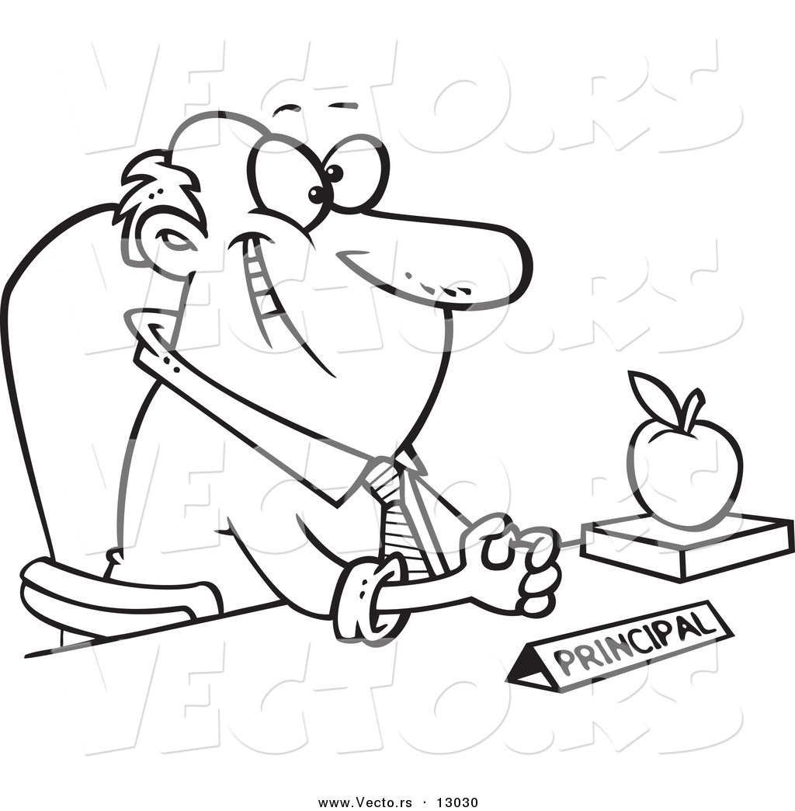
DANIEL HANDLER
Principals and Principles

In San Francisco the weather never gets hot, and when it does it lasts only three days. On the first day, the hot weather is a surprise, and everyone wanders around carrying their sweaters. On the second day, everyone enjoys the heat. And on the third day, the cold weather returns and is just as surprising, and everyone wanders around shivering.
One of these three-day heat waves arrived when I was in seventh grade, and on the first day everyone was grumpy because we had all dressed for fog and gloom and now had to drag our sweaters all over the school. We all agreed that the next day we’d dress for warm weather, but just as the day ended, the principal made an announcement over the loudspeaker. “Students at Herbert Hoover Middle School are not allowed to wear shorts,” she said, in the tone of voice she always used- a tone of voice that sounded friendly but was actually unbearably wicked.
Everyone groaned- everyone but me. “She can’t do that,” I said, and reached into the back of my binder. On the first day of school, we’d all received a pamphlet: “Student Rights and Responsibilities.” For some reason I’d saved it, and I read one our rights out loud: “Students have the right to free dress.” I convinced everyone to wear shorts the next day in order to protest the wicked principal’s unfair cancellation of one of our rights.
The next day was wonderful because we were all dressed for the heat and nobody had to drag their sweaters around, but of course, I was sent to the principal’s office- someone had ratted on me. (To this day, I suspect Nancy Cutler, but I can’t prove it.) She asked me if I had told everyone to wear shorts. I said yes. She said shorts were distracting to some of the teachers. I said that free dress was one of our rights. She said that shorts led students to have water fights. I said that free dress was one of our rights. She said that she was the principal and she was in charge. I said that free dress was one of our rights. She kept pointing at me. I kept pointing at the pamphlet. The principal was one of those people who yelled at you until you cried, but I forced myself not to cry, biting my lip and blinking very, very fast, until at last she gave up and I was allowed to return to my classmates, who applauded me. In celebration, we all wore shorts the next day, too, even though we knew the cold weather would return, and it did, and we were shivering and miserable.
In eighth grade we got a new version of the pamphlet. Instead of “Students have the right to free dress,” it read, “Students have the responsibility to dress appropriately.” I threw it away.
If you stand up for your rights, you can count on the fact that people will find sneaky ways to change the rules. But you should stand up for your rights anyway, because there aren’t enough sunny days in the world, and everyone should enjoy them.

Handler, Daniel. "Principals and Principles." Jon Scieszka Presents Guys Write for Guys Read. New York: Penguin Group, 2005. 112-113.

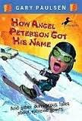
GARY PAULSEN
from How Angel Peterson Got His Name
I had written a book about my life with my cousin Harris and talked about Harris and talked about Harris peeing on an electric fence. The shock made him do a back flip and he swore he could see a rainbow in the pee. Many readers, especially women, were amazed that a boy would be insane enough to do this and didn’t believe that it had happened. However, I did get many letters from men saying that either they or a brother or cousin or friend had tried the same stunt, with some exciting results. One man said it allowed him to see into the past.
I was sitting writing one day when my son, then thirteen, came into the house with a sheepish look on his deathly pale face. As he passed me, I couldn’t help noticing that he was waddling.
“Are you alright?” I asked.
He nodded. “Sure…”
“Why are you walking so funny?”
“Oh, no reason. I was doing something out by the goat barn and thought I’d try a little experiment…”
“Pee on the electric fence?”
He studied me for a moment, and then nodded. “How did you know?”
“It’s apparently genetic,” I said, turning back to work. “It’s something some of us have to do. Like climbing Everest.”
“Will I ever stop doing things like this?”
And I wanted to lie to him, tell him that as he grew older he would become wise and sensible, but then I thought of my own life: riding Harley motorcycles and crazy horses, running Iditarods, sailing single-handed on the Pacific.
I shook my head. “It’s the way we are.”
“Well,” he sighed, tugging at his pants to ease the swelling, “at least I know what that’s like and don’t have to pee on any more fences.”
And he waddled into his room.

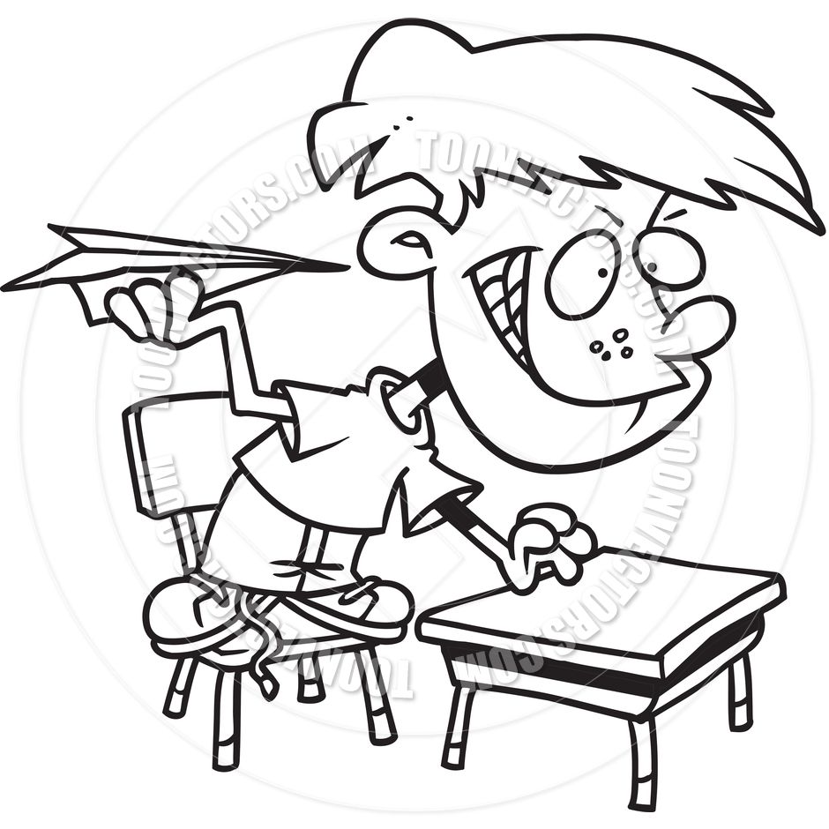
JACK GANTOS
The Follower

My mother said he was trouble the first time I met him. His name was Frankie Pagoda and he had just been catapulted across his yard like a human cannonball and landed badly in ours. He was moaning as I stood over him, not knowing what to do. He was on his back and at first he wasn’t moving, but slowly he began to gyrate his arms and legs like a stunned crab.
“Who are you?” I asked.
“Frankie…P-“he slowly replied. “Frankie Pagoda.”
He was in a lot of pain, and here’s what was going on. His older brother, Scary Gary, who had already been in trouble with the law, had made him climb to the very top of a reedy Australian pine tree with a rope between his teeth. Then he tied the rope to the top of the tree and Gary tied the other end to the winch on Mr. Pagoda’s tow truck. He winched the top of the tree all the way down so it made a big spring and then Frankie held on like a Koala bear while Gary cut the rope with a machete. Frankie was launched like the stones the Romans flung at the Vandals.
I was in my bedroom and Mom was in the kitchen; both of us had windows that faced the backyard. Then we heard that first Whoosh! of the tree and Frankie hollering, “Ahhhhhh!” That was followed by a thud and a very soulful moan. And this is how we found him- on his back with his arms and legs slowly stretching out.
“Are your okay?” I asked. He slowly turned over onto his hands and knees.
“Yeah,” he said, wincing. “I’ve had worse.”
Mom pointed at him as if he were a garden pest. “He’s a heap of trouble,” she said to me. Then she said to Frankie, “If you have to hurt yourself, please do it in your own yard.”
He seemed to nod to that and I helped him up and he ran off. A few minutes later we heard, Whoosh! “Ahhhhh!” Thud! “Ugh!” He was back.
“Something is messed up with those people,” Mom said, chopping up onions that evening. “Something’s wrong in their heads.”
Maybe there was something wrong with me, too. I was different from Frankie but still, the first moment I saw him in pain, it occurred to me that I wanted to be in pain, too.
That evening my mother came into my room. “If I ever catch you playing with that kid or over at their house, you will be in big trouble. This is just a friendly warning,” she said.
“Why?” I asked. “He’s a neighbor and will probably be a friend.”
“You should not be friends with kids who are a danger to themselves and others.”
I got some courage up and replied, “That’s what I love about him.”
She pointed a red finger at my chest. “You are a follower, not a leader,” she said bluntly. “You are putty in the wrong hands. Don’t get me wrong. You’re a nice kid, but you are most definitely a follower.”
I sort of knew this was true but I didn’t want to admit it to her. Plus, a little of me still wanted to believe that I was strong, that I was my own man a great leader.
But within a week I was Frankie’s man, which was pretty scary because he was Gary’s man, which made me low man on the totem pole- or pine tree. The first time Gary launched me, I hit a car. It was an old Mercury Cougar parked in their backyard. It didn’t have any wheels and sat on its belly like a cat crouching to catch a bird. I hit the roof, which was like a steel trampoline. It dented down and popped up and I went springing off the top. As I was in the air, I kept thinking, When you hit the ground, roll and tumble and it won’t hurt so much. This is what I had learned from watching Roller Derby on TV. It was my favorite show and very violent, but the players always avoided massive debilitating and life-threatening injuries as long as they rolled and tumbled across the wooden track or over the rails and into the rows of metal folding chairs. So, as I flew through the air, I stared at the grassy yard and planned my clever descent. I hit the ground with my outstretched arms and, instead of bouncing as if my hands were shock absorbers; I collapsed into the ground like a piece of space junk.
I dislocated the finger on my right hand, bruised the side of my face, and sprained my right shoulder. I limped home hunched over like Quasimodo and went straight to my room. A few minutes later I was barking in pain from relocating the joints in my fingers. I was so afraid my mother would see my bruised face that I stole my sister’s makeup and powered my bruise. At dinner I couldn’t use my right arm. It hung limply by my side like an elephant’s trunk. I must have pinched a nerve on contact with the ground that left my arm paralyzed. Perhaps for life. I ate with my left hand and food kept falling down my chin and shirt and onto my lap.
“What’s wrong with your arm?” my mother asked.
“Nothing,” I mumbled.
She sneered, stood up, and came around to my side. She grabbed my arm and pulled on it like it was the started rope on a lawnmower engine. Something deep inside my shoulder went Pop!
“Arghhh,” I sighed. The relief from the pain was heavenly.
“You are as dumb as a post,” my mother said. “I’m warning you- don’t play with that kid! He’ll lead you to your death.”
I couldn’t help myself. The next day I felt pretty good and my teeth no longer throbbed when I breathed through my mouth. As soon as my mother went into the bathroom I ran over to Frankie’s house. His brother Gary had rigged up an electric chair with a train transformer. He ran copper leads from the transformer to chicken wire on the chair seat and duct-taped it down.
“Don’t be a chicken,” he said demonically when he saw me. “Take a seat.”
I did and it was torture at its most challenging. When I got home I looked at my naked butt in the mirror, and it was singed with the same chicken wire pattern that was on the chair. “Wow,” I said. “Pretty cool.”
The next day my mother did the laundry. She came to me with my pants, which were singed with the same wire pattern. “You don’t have to tell me how this happened,” she said. “You just have to stop. Whatever drives you to do this stuff is a sickness. So I’m grounding you for a while until your start displaying some sense.”
Maybe I was sick. Maybe I was a follower. But I couldn’t help myself. I wanted to sneak back for more. I was just thinking of crawling out the window when I looked over at the Pagoda house, and Frankie had his bike up o the peak of his roof. He was poised to pedal down the slope and land in the pool, which was quite a distance from the eaves of the house.
“Go!” Gary demanded. Frankie did. He pedaled as fast as he could and yelled all the way down and then was in the air. My vision was blocked by a bush, and instead of a splashing sound there was the springy metal sound of his bike hitting the concrete patio and clattering around. In a minute Gray was hollering at him to stop being a sissy and to get up and the dent in his forehead wasn’t anything to cry over. I rubbed my hand over my forehead. Perhaps a little dent of my own would look good, I thought.
The ambulance arrived in a few minutes. After some begging, Mom allowed me to visit Frankie in the hospital, and later, once Scary Gary was sent off to a special program for dangerous boys, I even snuck over to Frankie’s house a few times. He recovered just fine. And because he stopped doing dumb things for Gary, I stopped doing dumb things for him. He was a follower too, like me. And when you put two followers together nothing really bad happens. We didn’t get hurt for a while or do anything too stupid. About a month went by before I secretly hoped Scary Gary would return home and rescue us from being so dull. I was bored out of my mind.

TEDD ARNOLD
Reading Can Be Dangerous

Yes, dangerous. It’s true. Like when you read that history assignment on the way to school while riding your bike. Or when you get lost in a book and don’t know what’s going on around you—like when you’re all wrapped up in the exciting last chapter of Skateboard Monkey and a shadow falls across the page and you realize your teacher is standing there waiting for you to answer the question she asked you at least a half hour ago and your whole class is grinning at you, eager to witness your doom.
What happened to me wasn’t that bad. But I still remember one of the times I got lost in a book, back when I was a teenager. I was, along with lots of other guys, reading every James Bond spy novel I could get my hands on. (We’re talking 1960’s, if you must know.) One day I was home alone, enjoying my favorite food—a heaping plate of leftover spaghetti and meatballs. And I was reading. No, I wasn’t just reading. I was gripped, absorbed, like, not even in the building anymore—totally checked out—lost in a cool James Bond book.
My family had this pet bird, a big white cockatoo named Luke. He mostly hung out on a perch just inside our sliding glass patio doors, but he was free to fly around in the house. Luke couldn’t talk like some trained birds, but that didn’t stop him from chatting with people. His talk sounded like chuckling.
So, I’m at the table eating and reading, and Luke’s talking to me, and I’m not paying any attention. I don’t hear him. I don’t see him. I don’t know anything that isn’t on the plate or on the page in front of me.
Oh, did I mention? Luke lo-o-o-o-oved spaghetti.
Somewhere in his little bird brain, Luke must have decided I wasn’t being sensitive to his feelings. He took matters into his own hands, er feet. He flew from his perch, swooped over the top of my book, and landed right on my spaghetti and meatballs.
I didn’t mean to hurt him, I swear! But I didn’t have time to think. My first reaction was the same that yours would be. I knocked him off my food with the back of my hand.
Luke’s first reaction was to hold on to whatever he could. He clutched at my spaghetti with both feet. He went backwards head over heels and the spaghetti he grabbed went flying. Up the front of my shirt. Up my face. Up the wall behind me. Somehow, red sauce even splattered the ceiling.
Luke staggered to his feet and flew back to the perch, his butt feathers dripping spaghetti sauce all the way. He wasn’t hurt, except for his dignity—but the sauce on his beautiful white plumage turned him splotchy orange for weeks after. And I had quite a mess to clean up.
So when you’re reading one of those good books out there, be sure to take all the appropriate safety precautions. Because one day at the library you may find a James Bond novel with greasy red spots in the middle and you’ll know it’s true—reading can be dangerous.

Arnold, Tedd. "Reading Can Be Dangerous." Jon Scieszka Presents Guys Write for Guys Read. New York: Penguin Group, 2005. 30-32.

DAVID BAUER
My Entire Football Career

People often ask me, “What’s your favorite sport?” My answer is always the same: “Baseball.”
But I grew up in Texas, and in Texas football was, and forever will be, king. I liked football a lot and played it all the time in my backyard and in my friends’ backyards. And I played it pretty well. I was kind of small and was, let’s say, not fast, but I could throw and catch a football as well as most of my buddies and better than a lot of them.
Just before sixth grade, my family moved to another house and a different school, and when I got there I found out that my new school had a six-man football team with uniforms and a schedule and everything. Whoa, I thought, this is cool, and they said I could join. The problem was that the team had already been practicing and, for reasons I couldn’t fathom, they were all out of uniform jerseys. “You’ll just have to get a jersey of your own,” Coach said. The team’s jerseys were a shiny deep green with white numbers, sort of like the Philadelphia Eagles’. Nowadays, you could easily go out and buy a green jersey with white numbers. Back then it wasn’t easy at all. “Don’t worry,” said my mother. “I’ll just get you a plain jersey and dye it green.”
“Okay, but what about the numbers, Mom?”
“No, I can’t make numbers,” she said.
On the night before our first game, she presented me with my new jersey. A sick feeling filled my stomach. The jersey was the putrid color of canned English peas. Or stagnant pond water. It had no shine. And, as promised, no numbers. “Mom,” I finally said, “I can’t wear that.” That was a mistake, of course.
“Well,” she said, “I’m so sorry I couldn’t make you a perfect uniform. I spent all day doing this for you and that’s the thanks I get?” I was no match for her dual weapons of guilt and shame and quickly agreed that I was sure it would be fine.
As I trotted onto the field the next day to join my teammates in warm-up, I was consumed with new-guy dread. I knew how pathetic I looked. With my numberless pea-green jersey and oversized white helmet, I looked more like a cauliflower than a football player. I prayed that maybe these guys wouldn’t pay any attention. “Your jersey looks like puke!” yelled my teammate Sam. And Sam was my new best friend. The rest of them just started laughing hysterically.
Six-man football, in the sixth grade, is really more like three-man football, at least on offense. You have a quarterback and a running back and an end. The other three are linemen, including the center. The big three do almost everything; the linemen do almost nothing. Our quarterback was Danny Armstrong, who was big and, I thought, very aptly named. Our running back was Teddy Vanderslice, who made terrible grades but could run faster that most horses. Sam was the end. I was the center.
Early in the game, as I was still getting used to the weird noises inside my helmet, I snapped the ball to Danny, who went back to pass. I took a couple steps forward and turned to look back at Danny and see how the play was going. Not well. Both Sam and Teddy were covered and Danny was scrambling. Suddenly he looked right into my eyes and drilled a pass straight at me. I didn’t even know I was an eligible receiver. Apparently I was.
I reacted brilliantly: as the ball came straight and hard into my gut, I wrapped my arms tightly around it. Two-yard gain! But with the surprise of the moment and the force of the throw (I’d like to say there was a vicious tackle, but I can’t), I fell backward. I lay on the ground, still holding the ball tight to my stomach, and realized I could not breathe. For approximately forty-five minutes, or so it seemed, no air came into my body or went out of my body. Eventually, Coach came out to see why his pea-green center was still on his back on the ground. “What’s the matter, kid?” he asked, with no trace of sympathy. They were silent but I could hear their thoughts: Hey, the new kid’s a weenie. I could say nothing.
After what must have been several more hours without breath, Coach grabbed the waist of my pants and pulled me up in the air, lowered me, and pulled again. Life rushed back into my lungs. I had survived, but my teammates were less than impressed. “At least he didn’t puke on his puke jersey!” said my best friend Sam. More hysterical laughter. The humiliation was total, and all for two yards.
I finished the game, and I finished the season, though I remember none of it. I had already decided that it was time for a career change.
And that’s why I love baseball.
Bauer, David. "My Entire Football Career." Jon Scieszka Presents Guys Write for Guys Read. New York: Penguin Group, 2005. 33-35.

DAN GREENBURG
My Superpowers
Do you ever wish you had superpowers?
When I was a kid, growing up in the North Side of Chicago and being picked on by bullies, I prayed for superpowers. Like Superman, I wanted to be able to fly faster than speeding bullets, to be more powerful than locomotives, to leap tall buildings at a single bound. Mainly, I wanted to punch bullies in the stomach so hard that my fist came out of their backs.
Winters in Chicago are so cold that frost forms leafy patterns on your bedroom window and stays there for months. The wind howls off Lake Michigan, and a thick shell of pitted black ice covers the streets and sidewalks from December to April. To keep warm in winter, I wore a heavy wool coat, a wool muffler, wool mittens, furry earmuffs and –one of my most treasured possessions—a Chicago Cubs baseball cap autographed by a player named Big Bill Nicholson.
On the coldest days of winter, three bullies waited for me after school, just for the fun of terrorizing me. The biggest one was a fat ugly kid named Vernon Manteuffel. Vernon and his two buddies would pull off my Cubs cap and tease me with it. They’d pretend to give it back, then toss it around in a game of keep-away.
One day in February when the temperature was so low I felt my eyeballs cracking. Vernon and his friends caught up with me on my way home. As usual, they tore off my Cubs cap and started playing catch with it. What made it worse than usual was that on this particular day I happened to be walking home with a pretty girl named Ann Cohn, who lived across the street from me. Ann Cohn had green eyes and shiny black hair and I had a goofy crush on her. As if it wasn’t bad enough that these guys humiliated me when I was alone, now they were doing it in front of Ann Cohn.
I was so embarrassed, I began to cry. Crying in front of Ann Cohn made me even more embarrassed. I was speechless with shame and anger. Driven by rage, I did what only an insane person would do: I attacked Vernon Manteuffel. I punched him in the chest and grabbed back my Cubs cap.
Vernon saw that I had become a madman. People don’t know what to do with madmen. Vernon looked shocked and even a little afraid. He backed away from me. I attacked the second boy, who also backed away from me. Encouraged by their backing away, I ran after them, screaming, punching, flailing at them with both fists. I chased them for two blocks before they finally pulled ahead and disappeared. Breathing hard, tears streaming down my face, I felt I had regained my honor, at least temporarily.
That weekend, perhaps made braver by my triumph over the three bullies, I kissed Ann Cohn on her sofa. I can’t tell you exactly why I did that. Maybe because it was a cold, cloudy Saturday and there was nothing else to do. Maybe because we both wondered what it would feel like. In any case, I could now brag that, at age eight, I had personally kissed an actual girl who wasn’t related to me.
I never did get those superpowers. Not as a kid, at least.
When I grew up, I became a writer. I discovered a particular pleasure in going on risky adventures. I wrote about my real-life adventures for national magazines. I spent four months riding with New York firefighters and running into burning buildings with them. I spent six months riding with New York homicide cops as they chased and captured drug dealers and murderers. I flew upside-down over the Pacific Ocean with a stunt pilot in an open-cockpit airplane. I took part in dangerous voodoo ceremonies in Haiti. I spent time on a tiger ranch in Texas and learned to tame two-hundred-pound tigers by yelling, “No!” and smacking them hard on the nose. I found that tigers were not much different from the bullies of my childhood in Chicago.
I also wrote fiction. I created entire worlds and filled them with people I wanted to put in there. I made these people do and say whatever it pleased me to have them do and say. In the worlds I made up, I was all-powerful—I had superpowers.
I began writing a series of children’s books call The Zack Files, about a boy named Zack who keeps stumbling into the supernatural. In many of these books I gave Zack temporary powers—to read minds, to travel outside his body, to travel back into the past, to triumph over ghosts and monsters. I created another series call Maximum Boy, about a boy named Max who accidentally touches radioactive rocks that just came back from outer space and who suddenly develops super powers. Maximum Boy is me as a kid in Chicago, but with superpowers.
Oh yeah, I almost forgot. In The Zack Files, I created a fat, stupid kid who sweats a lot and thinks he’s cool, but who everyone laughs at behind his back. You know what I named this fool? Vernon Manteuffel. I do hope the real Vernon knows.

Greenburg, Dan. "My Superpowers." Jon Scieszka Presents Guys Write for Guys Read. New York: Penguin Group, 2005. 91-93.

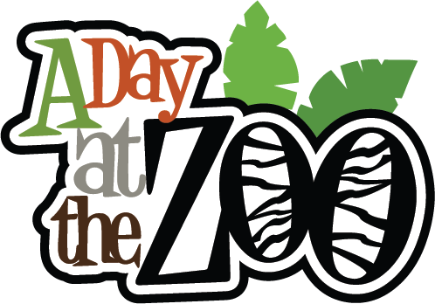
JACK PRELUTSKY
A Day at the Zoo

Okay…here’s a true story from when I was about twelve or maybe fourteen years old. I never told it to my mother, because I’m sure she would have dropped dead on the spot. About a year later, I did tell my father, who rolled his eyes and thought it was sort of funny.
It all happened in the Bronx in the early 1950’s. The Bronx is where I grew up and hung out with a guy named Bobby. We were great friends, because we had so much in common. Both of us could eat more of anything than anyone else we knew, and we were both experts at drinking milk and making it come out of our noses. We also got beat up by the same bigger kids.
The two of us also shared an interest in wild animals, and we were lucky to live just a couple of miles from the Bronx Zoo, one of the most famous zoos in the world. We went there often and always walked, not because we enjoyed walking all that much, but because we didn’t have a whole lot of money. By saving on bus fare, we could afford to get a few hamburgers or hot dogs along the way. Then, while still digesting our food, we often worked on our belching technique.
Anyhow, it was the summer, and we were at the zoo. Both of us had cheap little cameras. I don’t remember what Bobby’s was, but mine was an old Kodak Brownie that my father had loaned me. It was a simple camera, good enough for taking close-ups of animals in cages, but practically useless for photographing anything at a distance.
We’d spent an hour or so snapping pictures of seals and leopards and keeping our distance from a certain famous monkey. The monkey was famous because he liked to throw his poop at people. His aim as pretty good…that’s why we kept our distance. We decided to go over to an area called African Plains, a natural habitat ruled by lions, and without any ugly bars. A deep, very steep moat was the only barrier that kept the lions away from the folks visiting the zoo.
I took a few pictures of the lions, but felt frustrated because my little camera made the lions look like featureless clumps of tawny lint. I tried figuring out ways of getting closer…a lot closer. It occurred to me that if I went down into the moat, I’d get really close to the lions. There were numerous signs advising not to do this, but I paid them no attention. Bobby watched, with what I took to be admiration, as I climbed over the short fence, crossed a short level expanse, and slid down a practically vertical wall into the moat. As soon as I was at the bottom, I began snapping photos of the lions. This was great! They were so close now that I was getting some really good pictures, the best I’d ever taken. I was so involved with what I was doing that I failed to notice that several of the lions had taken an interest in me, and were casually inching toward the moat.
That’s when a zookeeper, on the point of hysteria, suddenly appeared at the top of the wall. He screamed so loud that he startled me out of my photographic reverie. “What the hell are you doing down there? Are you crazy? Get back up here you idiot, and I mean now!”
I looked up at him, and replied innocently, “Why? The lions can’t come down here. I’m safe. I’m O.K.”
The zookeeper screamed even louder. “No, you’re not. They can’t climb up this side, but they can get down to where you are…And they haven’t been fed yet!”
A chill ran down my spine as I looked behind me and saw one of the lions leisurely sauntering down into the moat, heading in my direction. I wondered if he could smell the burgers on my breath. Suddenly, I was so scared that I began to belch uncontrollably. Still belching, I managed somehow to claw my way up the top of the wall in a fraction of the time it had taken me to get down…I’d never moved so fast in my life. The zookeeper grabbed me by the collar and pulled me back over the fence.
He gave me a dirty look and said, “You’ve got to be the dumbest kid I’ve ever seen. Now get out of here…I don’t want to see you again.” By way of an exclamation point, he added a not-so-little slap to the side of my head.
I took his advice without saying a word and left, noticing that Bobby couldn’t stop laughing. On our way home I swore him to secrecy.
And that’s just one story I never told my mother.

Prelutsky, Jack. "A Day at the Zoo." Jon Scieszka Presents Guys Write for Guys Read. New York: Penguin Group, 2005. 192-194.

