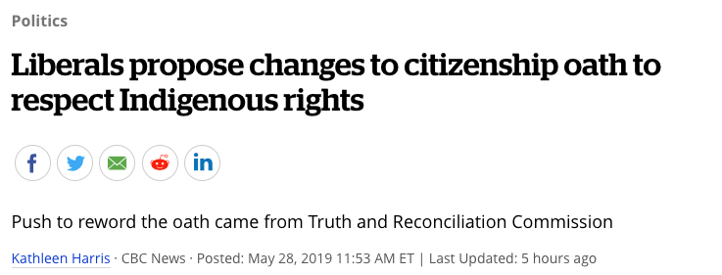

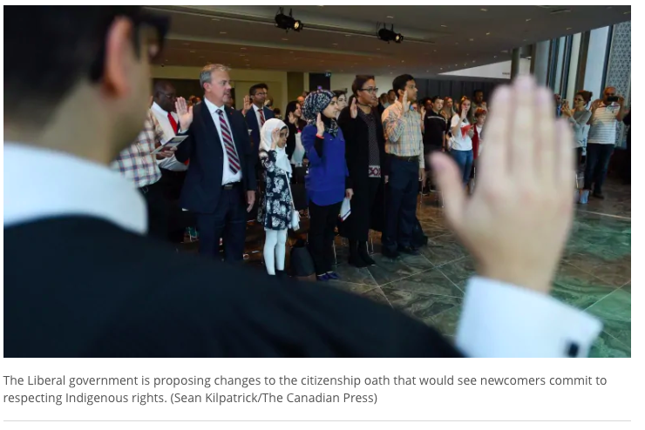

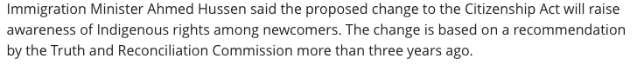

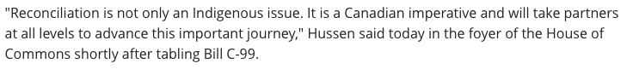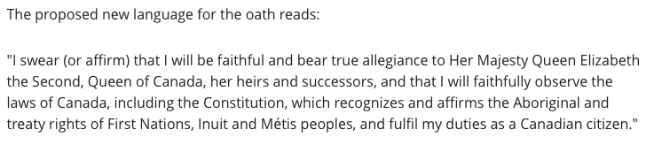
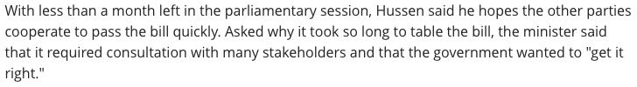

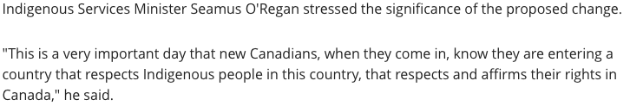

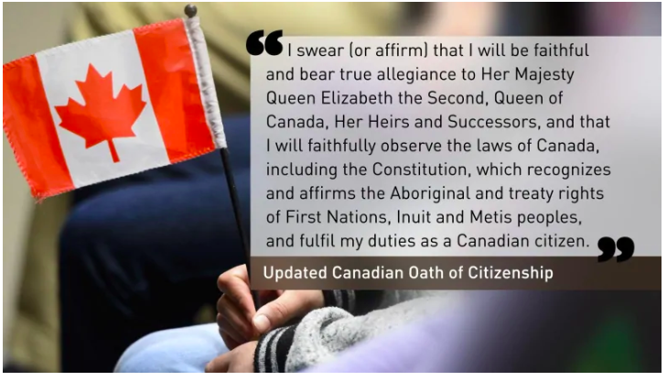

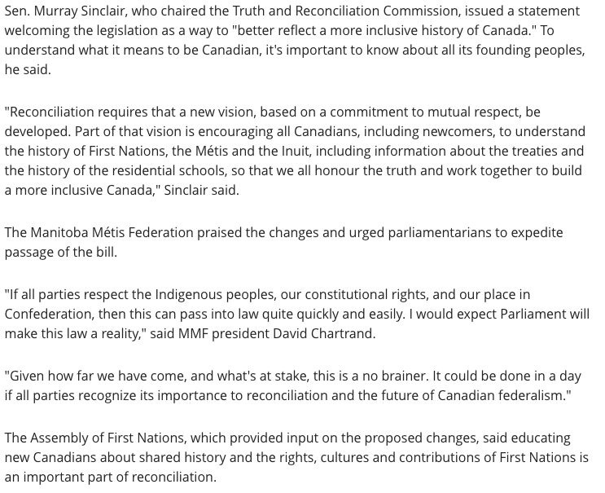

Long Answer

This proposed change to the citizenship oath—which new Canadians give upon receiving their citizenship—attempts to address some historical wrongs and is aimed to be a step on the path towards reconciliation. How might this change represent a significant move toward “building a more inclusive Canada”? Is this a worthwhile action to take? Explain.

