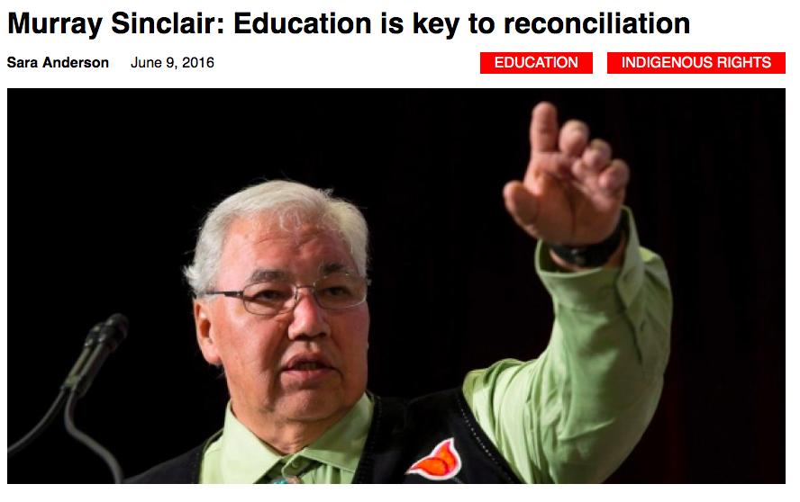

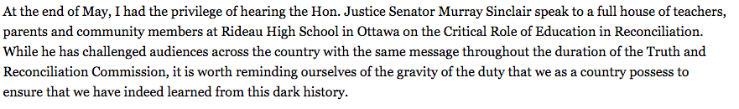
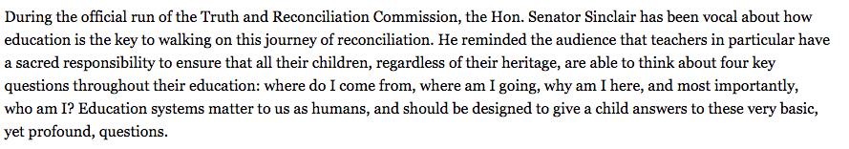

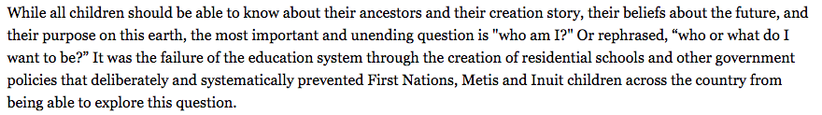

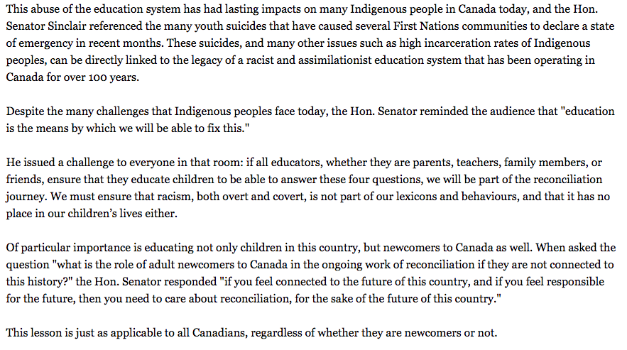
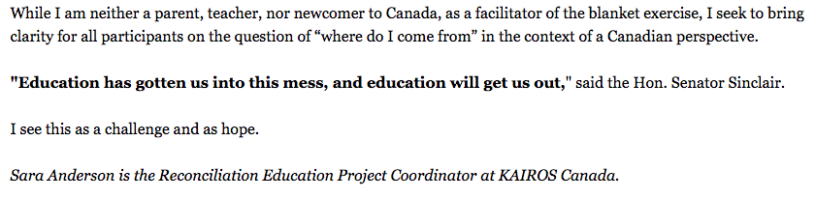

Education is the Key to Reconciliation
Long Answer

Sen. Murray Sinclair has, on many occasions, stated his belief that education contributed to the loss of identity and culture for Indigenous people of this country. To what extent do you agree with this view? Can education contribute meaningfully to the rebalancing of Canada’s fractured relationship, and who do you think should receive this education?

